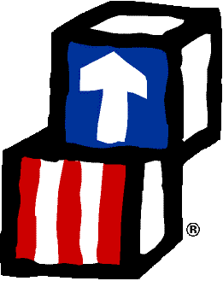
Community Action of Orleans and Genesee, Inc.
HEAD START
EARLY HEAD START
EARLY HEAD START – CHILD CARE PARTNERSHIP

October 28, 2025

Dear Families,


On November 1, several Head Start programs across the country may close due to the effects of the Federal government shutdown on their funding. Our hearts go out to those children, families and staff.

At this time, we remain……

To learn more about the impact of the shutdown to programs, visit the National Head Start Association at https://nhsa.org/take-action/. If you are interested, there is also information about making your voice heard.

Thank you for choosing Head Start.

Please feel free to reach out anytime,

Pam
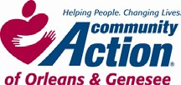
Pamela Wadhams, Director of Head Start
pwadhams@caoginc.org or (585)589-5683 x 118

